Three Tenants
Biznex.biz | Digitaldatamarts.com | Digitaldatalabs.onmicrosoft.com
reddyvelagala@biznex.biz | satyavelagala@digitaldatamarts.com | satyavelagala@digitaldatalabs.onmicrosoft.com
 | Jamessmith@digitaldatamarts.com

Created A group in Azure as Below and added 4 users ( out of three are Guest Users from other Tenant )

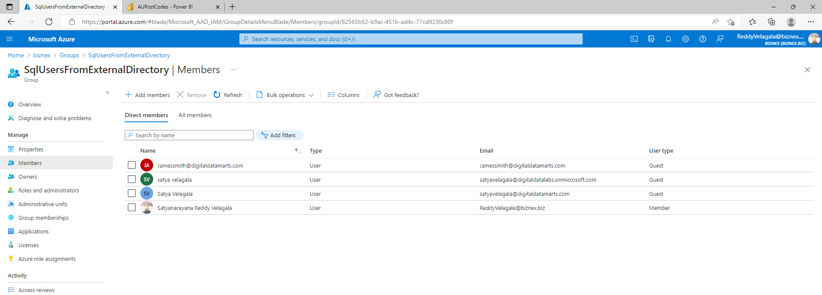

DB Server in biznex Tenant as below
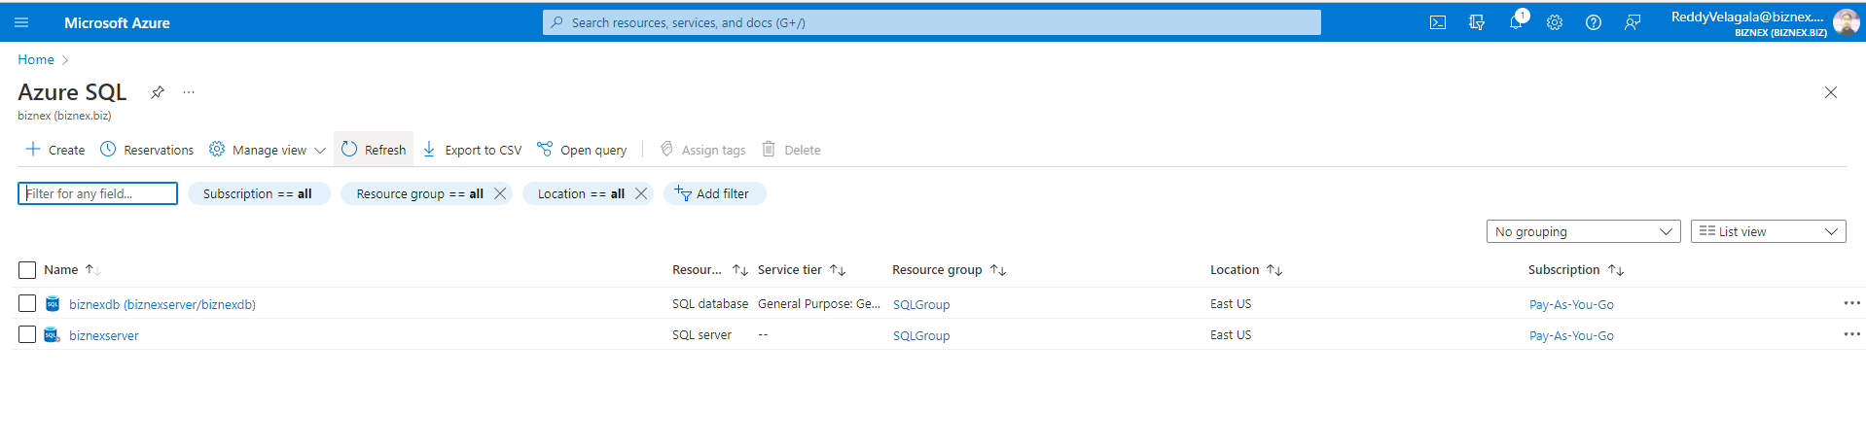
SQL Access
CREATE USER [SqlUsersFromExternalDirectory] FROM EXTERNAL PROVIDER

GRANT SELECT ON [dbo]. [AustraliaPostCodes] TO [SqlUsersFromExternalDirectory]

Reports access and view from above two Tenants

